IMPORTANT!!!!
Welcome to MRI!
Please read the important safety rules below to follow while working in our department. These rules are in place to ensure the safety of everyone, especially our patients.

- Complete the Employee MRI Screening Form. We will fax this to occupational health. This does not need to be completed again unless you have any implants placed. You cannot enter the MRI room (ZONE 4) until this is completed.
- Remove ALL objects from your pockets. Any objects that are ferromagnetic are considered projectiles, and are a safety hazard. If you will be in and out of the room (ZONE 4), we ask that you take them out when you arrive and keep them out.
- The following items are examples of items that need to be removed, and are not allowed in the MRI room:
  - Your badge! - The magnetic strip on your badge will be wiped, and you will not be able to swipe anywhere.
  - Phone/pager/Jabber
  - Ear pods/ headphones of any kind
  - Hair pins/hair clips
  - Credit cards/parking tickets with the mag strip
  - Ankle weights/braces with metal
  - Scissors
  - Stethoscope
  - Pens
- If you wear a dexcom, we recommend that you remove this before entering the room. The magnet will clear and distort the information on the dexcom.
- If you plan on going into the MRI room (ZONE 4), please close the door after you enter the room, and close the door when you exit the room.
- Do not bring any food or drinks into Zone 3.(Scanning tech area)
- Whatever you bring into the MRI room that is not used, please take back out with you and put away in the induction room. This includes any medications, airways, masks, and syringes. Do not leave anything behind on the WOW’s, especially medications. Any medicines left behind in our room at the end of the day, unattended, will result in a HERO.
- Refrain from using the WOW’s in our department that have a signature pad attached. These are reserved for MRI technologists that need to screen incoming inpatients.
- When the patient’s MRI exam is complete, and the patient is being moved from the MRI table to the recovery stretcher, please leave the MRI Pulse Ox on the patient until the portable Pulse Ox is on the patient and reading properly.

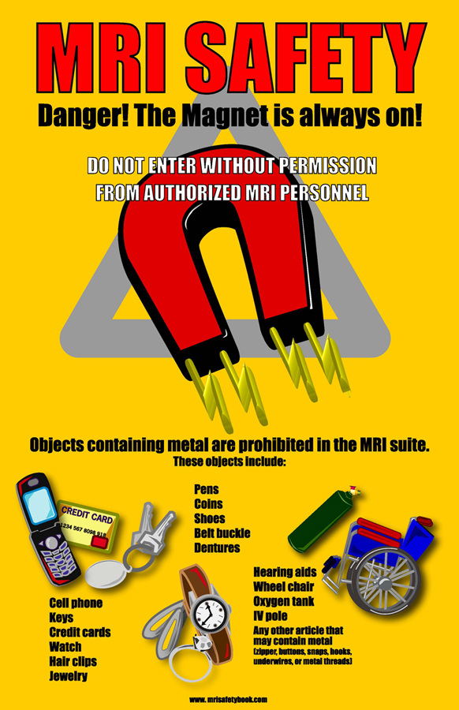
FYI
- Anesthesia is in charge of the induction room. The alcove outside of the induction room is always fully stocked with sheets for your stretcher. They are located in the cabinets next to the doorway. MRI is not in charge of cleaning or setting up this room.
- You will most always have a team of two MRI technologists working with you during your time in MRI
- When the patient is in the induction room, the induction room monitors will be used. When transferring the patient to the MRI room, these monitors will be switched out for MRI safe monitors.
- MRI will provide the EKG sticker that is compatible for both the induction room, and the MRI monitors. Please do not open and attach the pediatric EKG stickers to the induction room monitor. These contain metal, therefore MRI cannot use these as they will cause burns.
- The extended end-tidal/CO2 sample line that you need can be found in a blue bin on top of the anesthesia cart in the MRI room.
- All anesthesia carts in the MRI rooms are also stocked with an MRI safe stethoscope. Do not bring ANY stethoscopes into the MRI room.
- Please ask an MRI technologist before entering the MRI scan room to set up – this is to ensure there is not a patient currently in the scanner having an exam performed. Zayed 4 is scanning patients 24/7, you will most likely encounter this situation.
- Please check with your attending on the proper verbiage for connecting the monitors for charting.

***Feel free to ask us any questions you may have. We are looking forward to working together as a team with you!

