HEART CENTER SPINAL DRAIN INTRAOPERATIVE PRIMER
Spinal Drain
Paraplegia following thoracoabdominal aortic anuerysm (TAAA) surgery and thoracic endovascular aortic repair (TEVAR) is one of the most feared complications of the procedure with a resultant high morbidity associated with its occurrence (8-20%) (Coselli JS, Jacobs MJ, Cheung AT et al, Buth J, Khoynezhad A, Xenos E, Gutsche JT). While surgical techniques have advanced to prevent cord ischemia with shorter cross clamp times, re-anastamosis of segmental arteries, and distal aortic perfusion; CSF drainage is the most frequently used spinal cord protective measures practiced (Weigang E et al). According to the 2010 AHA Guidelines for the Management of Thoracic Aortic Disease, the use of CSF drainage for thoracic aortic procedures is the only Class 1 recommendation for protection of the spinal cord (Circulation 2010; 121:e266-e369). The theory behind the benefit of CSF drainage is rooted in the understanding that spinal cord perfusion pressure (SCPP) is equal to the systemic mean arterial pressure (MAP) minus the cerebrospinal fluid (CSF) pressure. Thus, decreasing the CSF pressure with external drainage will lead to higher SCPP. The spinal cord relies on several small plexiform posterolateral spinal arteries for blood flow along with a longitudinal anterior spinal artery. The intercostal (radicular) arteries supply most of these anterior and posterior arteries with the largest intercostal artery arising from T8-L1, commonly known as the artery of Adamkiewicz (Figure 1). During TAAA or TEVAR surgical manipulation and disruption of this artery is thought to lead to compromised cord perfusion and resultant cord ischemia. Risk factors for paraplegia include: prolonged aortic cross-clamp time, perioperative hypotension, old age, diabetes, severe atherosclerotic disease, emergency surgery, and more extensive or previously repaired aortic aneurysmal disease (Fedorow CA, Buth J).
Spinal Cord Perfusion Pressure: SCPP= MAP- (CSF or CVP {whichever is greater})
Daily production of CSF is 400-600mL with a circulating volume of 150mL in the spinal cord and cerebrum (Sakka L).
Spinal Drain Placement/Management Protocol
Preferably done 24 hours prior to surgery in the CSICU
Patient Consent
Preferably done awake although placement can be done in patients under general anesthesia (Estrera AL)
Confirm no recent infections or tattoos (Douglas MJ) in area of placement or allergies to equipment
Avoid placement if evidence of elevated intracranial pressure, abnormal neurocognitive exam
Check coagulation profile of the patient (Horlocker TT, Fedorow CA):
  - Platelets >100
  - INR< 1.3
  - Check recent medications given (Appendix 1)
Gather equipment:
- Spinal Drain Kit and Spinal Drain Monitoring System
- Epidural Kit
  - Drape
  - Lidocaine and Syringe for local infiltration
- Sterile gloves , gown, and hat (for 2 people)
- Large surgical sterile drape
- Nursing help
Connect to patient monitors prior to sedation:
- Pulse ox
- EKG
- Blood pressure
Position the patient:
- Lateral position preferred if having difficulty can use supine position
- L3/4 or L4/5 vertebral space (Boon JM)
Insertion Instructions:
- Prep and drape the insertion site in a sterile fashion. Apply local anesthesia to the potential insertion site.
- Prepare the CSF catheter with sterile preservative free saline flush followed by hydrophobic guideline insertion.
- Advance the 14 gauge Tuohy needle either through a midline or paramedian approach. Continue advancement through the dura until free flowing CSF drainage is confirmed around the stylet of the Tuohy. Conversely, some practitioners utilize a “Loss of resistance” technique to confirm epidural space then further advanced through the dura.
- Prior to removal of the stylet have the CSF catheter ready and gowned assistant available for immediate threading through the Tuohy.
- Remove the stylet once confirmation of continued CSF flow, advance the CSF drainage catheter approximately 10 cm into the intrathecal space (numbers are labeled on the catheter). Literature describes insertion up to 20cm but has a higher chance of parasthesia or nerve root injury (Cheung AT, Estrera AL, Fedorow CA)
- Then remove the Tuohy needle
- Then remove guidewire while keeping the catheter in place; apply gentle traction to guidewire. Avoid wrinkling the catheter as it may lead to tears.
- Confirm appropriate CSF drainage from the CSF catheter to ensure correct placement and intact catheter.
- Attach catheter adapter components to the proximal end of the CSF catheter (see Step by Step guide).
- Connect and retro-prime the CSF drainage/monitoring system with CSF then attach and zero the transducer to the phlebostatic axis. The transducer MUST NEVER be connected to a pressurized bag. ALWAYS connect the transducer to a saline filled syringe.
- Dress the catheter with benzoin, small tegaderm, followed by larger tegaderm, and tape up the patient’s right side to avoid surgical draping and prepping area. (Creating a small loop of the catheter near the insertion point helps avoid catheter kinking, check patency of catheter after surgical positioning).
- If placed 24 hours prior to surgery, drain 1mL (3 drops) of CSF hourly to maintain catheter patency
Tips for insertion:
If unable to thread catheter to 10cm, pull BOTH Tuohy needle and catheter out simultaneously to avoid catheter shearing.
Keep Tuohy needle stylet in place until absolutely ready to thread CSF catheter, avoiding excessive CSF drainage.
Once in the intrathecal space do not drop the end of the catheter below the insertion point, avoids accidental CSF draining.
Risks for Spinal Hematoma in a Heparinized patient: (Fedorow CA, Buth J)
- Less than 1 hour from the placement of drain to the administration of heparin
- Difficult or traumatic needle placement (consider delay of surgery for 24 hours)
- Concomitant use of other anticoagulants
- Patients with known coagulopathy
Management of a traumatic or bloody spinal drain placement:
- If placing day of surgery, consider cancelling or delaying surgery for 24 hours depending on urgency of surgery
- Reattempt at a different interspace
- Vigilance for perioperative neuraxial hematoma (50% of neuraxial hematomas were associated with a traumatic insertion) (Fedorow CA, Horlocker TT)
Possible Complications (High volume centers report 1.5% complication rate) (Estrera AL):
- Subdural hematoma
- Meningitis
- Excessive CSF leak causing spinal headache
- Severe CSF leak can cause intracranial bridging veins rupture and intracranial hemorrhage
- Catheter fracture
- Retained catheter
- Nerve root injury
- Ligament damage
Intraoperative management:
Connect the drain to pressure transducer that is zeroed at the phlebostatic axis (approx. the right atrium, the middle ear) (Figure 2) and reconfirm appropriate transducer position throughout the perioperative period.
Attempt to keep the CSF pressure less than 10-12mmHg (Estrera AL), SCPP > 70 mmHg, and MAP > 90 mmHG (Hnath JC)
Level spinal drain system at 13 cmH₂0 aligned with phlebostatic axis which is an approximate CSF pressure of 10mmHg to avoid accidental over drainage of CSF fluid past 10mmHg (Cheung AT).
Hourly drain CSF with continued monitoring of CSF pressure to avoid accidental over drainage (Fedorow CA, Estrera AL)
Drain approximately 10-15mL at a time with no more than 20mL in one hour for 4 hours (Fedorow CA, Leyvi G, Estrera AL).
Decreases in SSEP or MEP can signify a need to drain CSF, important to communicate with the neuromonitoring technologist.

References:
Fedorow CA, Moon MC, Mutch WA, Grocott HP (2010) Lumbar cerebrospinal fluid drainage for thoracoabdominal aortic surgery: rationale and practical considerations for management. Anesth Analg 111: 46-58.
Horlocker TT, Wedel DJ, Rowlingson JC, Enneking FK, Kopp SL, et al. (2010) Regional anesthesia in the patient receiving antithrombotic or thrombolytic therapy: American Society of Regional Anesthesia and Pain Medicine Evidence-Based Guidelines (Third Edition). Reg Anesth Pain Med 35: 64-101.
Sakka L, Coll G, Chazal J. Anatomy and physiology of cerebrospinal fluid. Eur Ann Otorhinolaryngol Head Neck Dis. 2011;128(6):309-16.
Yandrapalli S, Raza A, Tariq S, Aronow WS. Ambulatory pulmonary artery pressure monitoring in advanced heart failure patients. World J Cardiol. 2017;9(1):21-26.
Estrera AL, Sheinbaum R, Miller CC, et al., Cerebrospinal Fluid Drainage During Thoracic Aortic Repair: Safety and Current Management. The Annals of Thoracic Surgery, 2009; 88: 9-15.
Boon JM, Abrahams PH, Meiring JH, Welch T. Lumbar puncture: anatomical review of a clinical skill. Clin Anat 2004;17:544–53
Cheung AT, Pochettino A, Guvakov DV, Weiss SJ, Shanmugan S, Bavaria JE. Safety of lumbar drains in thoracic aortic operations performed with extracorporeal circulation. Ann Thorac Surg 2003;76:1190–7
Leyvi G, Ramachandran S, Wasnick JD, Plestis K, Cheung AT, Drenger B. Risk and benefits of cerebrospinal fluid drainage during thoracoabdominal aortic aneurysm surgery. J Cardiothorac Vasc Anesth 2005;19:392–9
Hnath JC, Mehta M, Taggert JB, Sternbach Y, Roddy SP, Kreienberg PB, Ozsvath KJ, Chang BB, Shah DM, Darling RC III. Strategies to improve spinal cord ischemia in endovascular thoracic aortic repair: outcomes of a prospective cerebrospinal fluid drainage protocol. J Vasc Surg 2008;48:836– 40
Coselli JS et al. Open surgical repair of 2286 thoracoabdominal aortic aneurysms. Ann Thorac Surg 2007;83:s862-s4.
Jacobs MJ et al. Assessment of spinal cord integrity during thoracoabdominal aortic aneurysm repair. Ann Thorac Surg 2002;74:s1864-s6.
Cheung AT et al. Interventions for reversing delayed-onset postoperative paraplegia after thoracic aortic reconstruction. Ann Thorac Surg 2002;74:413-21.

Buth J, Harris PL, Hobo R, van Eps R, Cuypers P, Duijm L, Tielbeek X. Neurologic complications associated with endovascular repair of thoracic aortic pathology: incidence and risk factors. A study from the European Collaborators on Stent/Graft Techniques for Aortic Aneurysm Repair (EUROSTAR) registry. J Vasc Surg 2007;46:1103–11

Khoynezhad A, Donayre CE, Bui H, Kopchok GE, Walot I, White RA. Risk factors of neurologic deficit after thoracic aortic endografting. Ann Thorac Surg 2007;83:S882–9

Xenos E, Abedi N, Davenport D, Minion D, Hamdallah O, Sorial E, Endean E. Meta-analysis of endovascular repair vs open repair for traumatic descending thoracic aortic rupture. J Vasc Surg 2008;48:1343–51

Gutsche JT, Szeto W, Cheung AT. Endovascular stenting of thoracic aortic aneurysm. Anesthesiol Clin 2008;26:481–99

Plecha EJ, Seabrook GR, Freischlag JA, Towne JB. Neurologic complications of reoperative and emergent abdominal aortic reconstruction. Ann Vasc Surg 1995;9:95–101

Weigang E et al. Perioperative management to improve neurologic outcome in thoracic or thoracoabdominal aortic stent-grafting. Ann Thorac Surg 2006;82:1679-87

Douglas MJ, Swenerton JE. Epidural anesthesia in three parturients with lumbar tattoos: a review of possible implications. Can J Anaesth. 2002;49(10):1057-60.

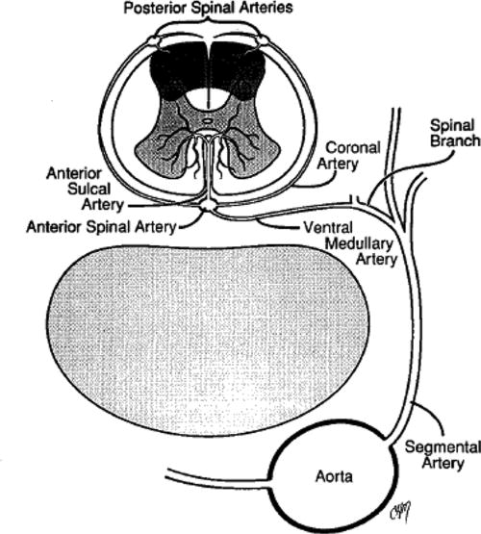
Figure 1 (Plecha EJ) Figure 2 (Yandrapalli)
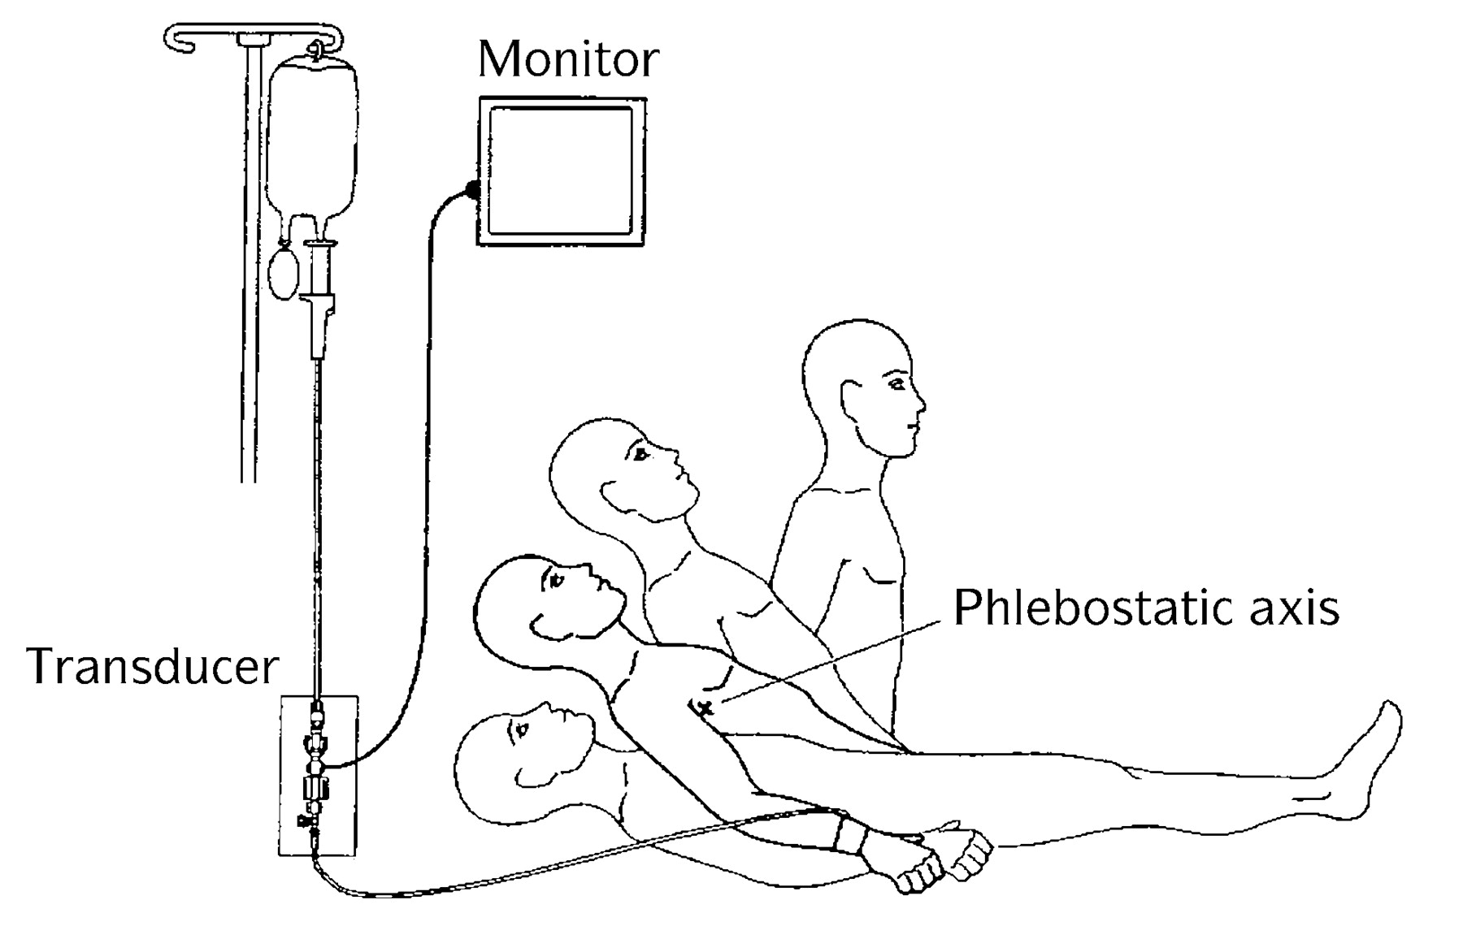

Appendix 1 (MGH Guidelines for Neuraxial Anesthesia)
DRUG (GENERIC) | COMMON TRADE NAMES | INTERVAL FOR CATHETER PLACEMENT OR NEURAXIAL PROCEDURE AFTER LAST DOSE | INTERVAL FOR CATHETER REMOVAL AFTER MOST RECENT DOSE | RECOMMENDED INTERVAL TO RESTART MED AFTER NEURAXIAL PROCEDURE OR REMOVAL OF EPIDURAL CATHETER
ASA | Asprin | See NSAID
ABCIXIMAB | REOPRO (Time to platelet aggregation for ABCIXIMAB/REOPRO is 24 - 48 hours) | 48 Hours | 48 Hours | 24 Hours
ALTEPLASE | ACTIVASE | 10 Days | 10 Days | 10 Days
APIXABAN | ELIQUIS | 2 days (CrCl>50); 3 days (CrCl<50 | 48 hours | 6 hours, 24 hours if Traumatic placement
ARGATROBAN | ACOVA | At least 6 Hours; check for normal PTT or ACT | Check for normal PTT or ACT | 2 Hours
BIVALIRUDIN | ANGIOMAX | At least 6 Hours; check for normal PTT or ACT | Check for normal PTT or ACT | 2 Hours
CILOSTAZOL (ALONE) | PLETAL | Placement and removal of catheter is okay
CILOSTAZOL (with ASA) | PLETAL | 48 Hours | 48 Hours | 2 Hours
CLOPIDOGREL | PLAVIX (75 mg) | 5-7 Days | *> 5 days (If single dose given, Urgent Anesthesia consultation and hold further dosing) | 24 Hours
CLOPIDOGREL* call cardiologist | PLAVIX (300 - 600 mg) | 7 Days | > 7 Days | 6 hours, 24 hours if Traumatic placement
DABIGATRAN | PRADAXA | 4 days (CrCL >50) 7days (CrCl <50) | at least 48 Hours | 24 Hours
DALTEPARIN (Therapeutic) | FRAGMIN (5000 units BID or 120 units/kg BID or 175 units/kg QD) | 24 Hours | 24 Hours | 4 Hours
DALTEPARIN (prophylactic) | FRAGMIN (</= 5000 units QD) | 12 Hours | 12 Hours | 4 Hours
Note: LOW MOLECULAR WEIGHT HEPARIN: Prophylactic dosing may be started 6-8 hours postoperatively. Therapeutic dosing or BID dosing should be started at least 24 hours postoperatively. Epidural catheters should be removed prior to initiation of therapy.
DESIRUDIN | REVASC | Uncertain, probably unwise to perform neuraxial block, check ACT |  | 2 Hours
ENOXAPARIN (Therapeutic) | LOVENOX (> 60 mg QD or 1mg/kg BID or 1.5mg/kg QD) | 24 Hours | 24 Hours | 4 Hours
ENOXAPARIN (prophylactic) | LOVENOX (</= 60 mg QD) | 12 Hours | 12 Hours | 4 Hours
Note: LOW MOLECULAR WEIGHT HEPARIN: Prophylactic dosing may be started 6-8 hours postoperatively. Therapeutic dosing or BID dosing should be started at least 24 hours postoperatively. Epidural catheters should be removed prior to initiation of therapy.
EPTIFIBATIDE | INTEGRILIN | 8 Hours | 8 Hours | 24 Hours
FONDAPARINUX (See Note) | ARIXTRA (2.5 mg) | 4 Days | 4 Days | 2 Hours
FONDAPARINUX (See Note) | ARIXTRA (5 mg, 7.5 mg, 10 mg) | 7 Days | >4 Days/monitor | 24 Hours
Note: FONDAPARINUX should not be given if regional anesthesia is anticipated or has been used. If, however, FONDAPARINUX is given, the above guidelines are suggested.
HEPARIN SC BID | HEPARIN | No Significant Risk at dose of 5000 units bid
HEPARIN SC TID | HEPARIN | Unknown risk at 5000 units TID: Suggest check PTT. 10,000 units TID: check PTT
HEPARIN IV | HEPARIN | 2-4 Hours, PTT < 35 | 2-4 Hours, PTT < 35 | 2 Hours
NSAID, ASA | CELEBREX, MOTRIN, NAPROSYN, etc | No Significant Risk
RIVAROXABAN | XARELTO | 2 days (CrCl > 50); 3 days (CrCl <50) | 48 Hours | 6 hours, 24 hours if Traumatic placement
PRASUGREL | EFFIENT | Not recommended; consult cardiology. Wait 5 days after termination of therapy | 10 Days | 24 Hours
STREPTOKINASE | STREPTASE | 10 Days | 10 Days | 10 Days
TICAGRELOR | BRILANTA | Not recommended; consult cardiology. Wait 5 days after termination of therapy. | Uncertain. Wait 5 days. | 24 Hours
TICLOPIDINE | TICLID | 14 Days | 14 Days | 24 Hours
TIROFIBAN | AGGRASTAT | 8 Hours | 8 Hours | 24 Hours
WARFARIN | COUMADIN | 3-5 Days, INR </= 1.5 | If > 24 Hours, check INR< /= 1.5 | Same Day

